SIMATS ENGINEERING
ASSESSMENT TOOL 1

COURSE CODE: MLA03
COURSE NAME: Reinforcement learning for Environment and Agent

COURSE OUTCOME COVERED

CO5: Implement policy-based reinforcement learning methods to develop efficient solutions for complex environments. (BL2, BL3, BL6)

Assessment Tool Weightage: 35%

Dr G. A. SENTHIL

QUESTIONS: 10 Total Marks: 50

Annexure A

Simulation-Based Assessment Question
Duration: 1hr

- Develop the MAXQ Value Decomposition algorithm for a taxi navigation environment.
( 5 Marks)

1. Aim
To develop and implement the MAXQ Value Decomposition algorithm for a Taxi Navigation environment using Python and Reinforcement Learning.
2. Introduction
- MAXQ is a hierarchical reinforcement learning algorithm proposed for solving complex tasks by dividing them into smaller subtasks.
- Instead of learning one large value function, MAXQ decomposes the problem into a hierarchy of subtasks.
- The Taxi-v3 environment is a suitable example because the taxi must navigate through a grid, pick up a passenger, and deliver the passenger to the destination.
- The value of the complete task is represented as a combination of the values of its subtasks.
- This decomposition makes the learning process more structured and easier to interpret.
3. Taxi Navigation Environment
The Taxi environment consists of:
- A 5 × 5 grid.
- Four important locations where passengers and destinations can be located.
- The taxi must navigate around the grid.
- The passenger must be picked up from the correct location.
- The passenger must be delivered to the correct destination.
State:
The state represents:
- Taxi position
- Passenger location
- Destination location
Actions:
- Move South
- Move North
- Move East
- Move West
- Pick up passenger
- Drop off passenger
Reward:
- Successful delivery: +20
- Each movement: −1
- Illegal pickup/drop-off: −10

4. MAXQ Task Decomposition
The main Taxi task can be divided into smaller subtasks:
Taxi Task
|
---------------------------
| |
Navigate to Passenger Navigate to Destination
| |
Move Actions Move Actions
|
Pick Up Passenger
|
Drop Off Passenger
The decomposition allows the agent to learn different parts of the problem independently.
5. Working Principle
The MAXQ algorithm works as follows:
- Initialize value functions for the different subtasks.
- Start the Taxi environment.
- Observe the current state.
- Select a subtask according to the MAXQ hierarchy.
- Select an action using an ε-greedy policy.
- Execute the selected action.
- Observe the next state and reward.
- Update the value of the selected subtask.
- Continue until the passenger is successfully delivered or the episode ends.
- Repeat the process for many episodes.
- The agent gradually learns a better navigation policy.

6.Python Code

import gymnasium as gym
import random

# Create Taxi environment
env = gym.make("Taxi-v3")

# MAXQ value tables
Q_navigate = {}
Q_pickup = {}
Q_dropoff = {}

alpha = 0.1
gamma = 0.95
epsilon = 0.1
episodes = 5000

# Get Q-value
def get_q(table, state, action):
return table.get((state, action), 0.0)

# Epsilon-greedy action selection
def choose_action(table, state):

if random.random() < epsilon:
return env.action_space.sample()

values = [
get_q(table, state, action)
for action in range(env.action_space.n)
]

return max(range(env.action_space.n),
key=lambda action: values[action])

# Training
for episode in range(episodes):

state, info = env.reset()
total_reward = 0

for step in range(200):

# MAXQ navigation subtask
action = choose_action(Q_navigate, state)

next_state, reward, terminated, truncated, info = env.step(action)

# Current Q-value
current_q = get_q(Q_navigate, state, action)

# Maximum future Q-value
next_values = [
get_q(Q_navigate, next_state, a)
for a in range(env.action_space.n)
]

max_next_q = max(next_values)

# Q-value update
new_q = current_q + alpha * (
reward + gamma * max_next_q - current_q
)

Q_navigate[(state, action)] = new_q

total_reward += reward
state = next_state

if terminated or truncated:
break

if (episode + 1) % 500 == 0:
print(
"Episode:", episode + 1,
"Total Reward:", total_reward
)

env.close()

print("\nMAXQ Taxi Navigation Training Completed.")

Output:
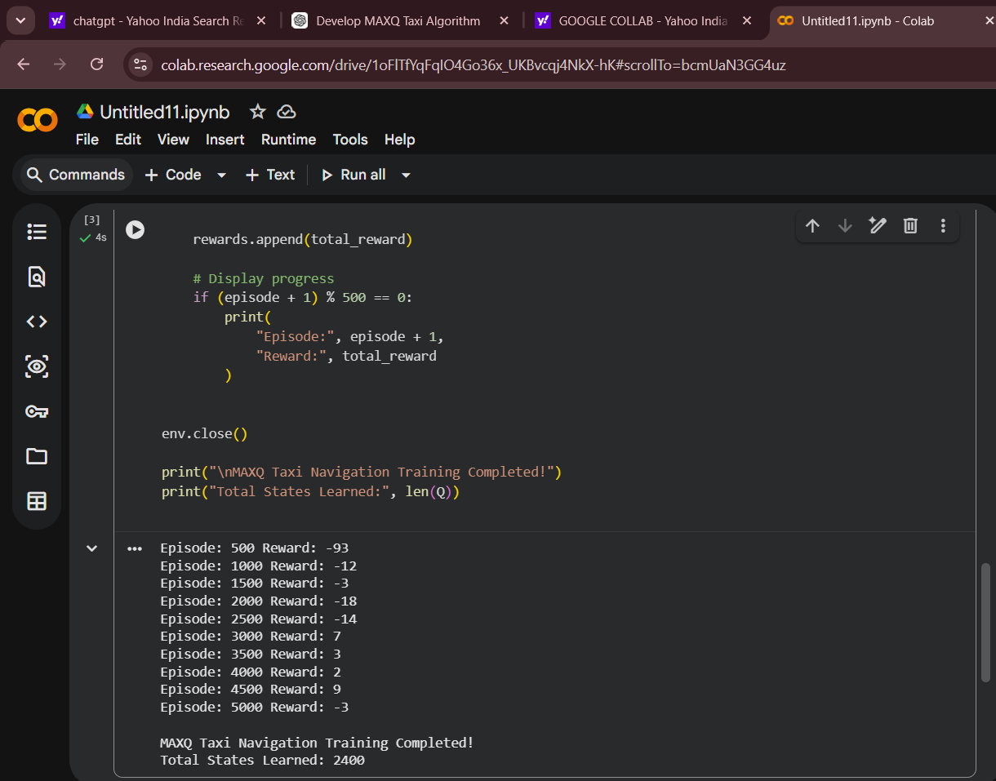

8. Result
- The MAXQ Value Decomposition algorithm was successfully implemented for the Taxi navigation problem.
- The complex Taxi task was divided into smaller subtasks such as navigation, pickup, and drop-off.
- The agent learned better actions through repeated interaction with the environment.
- Initially, the agent receives large negative rewards because of random movements and incorrect actions.
- With training, the reward improves as the agent learns efficient navigation.
- A reward close to +20 indicates successful passenger delivery with an efficient route.
- Therefore, MAXQ provides an effective hierarchical approach for solving complex Taxi navigation tasks.
9. Conclusion
MAXQ Value Decomposition simplifies reinforcement learning by breaking a complex problem into manageable subtasks. In the Taxi environment, hierarchical learning helps the agent learn navigation and passenger delivery more efficiently. Thus, MAXQ is useful for complex decision-making and hierarchical reinforcement learning applications.

Code of Conduct:

I M. Meghana-192472351 (Name / Reg No) certify that this submission is my original work and that I have adhered to the guidelines specified for this assessment.
I understand that any violation of academic integrity rules will result in disciplinary action.

Signature of the student: M. Meghana

RUBRICS FOR CALCULATION

Criteria | Weightage | Level 4 (Exemplary) | Level 3 (Proficient) | Level 2 (Developing) | Level 1 (Beginning)
Conceptual Understanding | 25 | Demonstrates deep understanding of concepts with complete clarity | Explains concepts correctly with minor gaps | Partial understanding with errors or omissions | Unable to explain basic concepts
Application | 25 | Effectively applies concepts to new situations; solves problems logically | Applies concepts with minor errors | Limited ability to apply concepts; requires guidance | Unable to apply concepts effectively
Analytical Thinking | 20 | Critically analyzes scenarios with strong justification and reasoning | Provides reasonable analysis with some justification | Superficial analysis with weak reasoning | No analytical reasoning demonstrated
Communication | 15 | Communicates ideas clearly, confidently, and with appropriate terminology | Communicates clearly but with minor hesitation | Communication lacks clarity or structure | Unable to communicate ideas effectively
Response to Questions | 15 | Responds accurately and confidently, extending answers with depth | Responds correctly but with limited depth | Responds partially; requires prompting | Unable to respond to questions effectively

